SIMATS ENGINEERING
ASSESSMENT TOOL 1

COURSE NAME: Artificial Intelligence COURSE CODE: CSA17

COURSE OUTCOME COVERED

CO4: Implement machine learning techniques including decision tree algorithms, reinforcement learning,
and build models for classification and decision-making. (BL3)

Assessment Tool Weightage: 20%

Duration: 1 Hour
QUESTIONS: 4 Total: Marks:40

Annexure A

INDUSTRY PROBLEM TASK

Code of Conduct:

I S. LAKSHITA(192524108) certify that this submission is my original work and that I have adhered
to the guidelines specified for this assessment.
I understand that any violation of academic integrity rules will result in disciplinary action.

Signature of the student:


Annexure A

INDUSTRY PROBLEM TASK

INDUSTRY SCENARIO
Context: A healthcare company has collected patient records (age, blood pressure, cholesterol, glucose level, BMI, family history) to build a predictive model for early diagnosis of diabetes. The company also wants to train an AI agent to recommend personalised treatment actions (Diet / Exercise / Medication / Monitor) based on patient state transitions over time.
You are hired as an AI/ML Engineer. Address the following tasks:
Task 1: Data Preparation & Inductive Learning
(a) Describe the inductive learning approach suitable for this medical dataset. Identify the target variable and at least three key features with justification.
(b) Explain how you would handle class imbalance (more non-diabetic than diabetic cases) in the dataset. Suggest and justify a suitable balancing strategy (SMOTE / under-sampling / class weights).
(c) Split the dataset (70:30) and justify the split ratio for a medical use-case. State the preprocessing steps (normalisation, encoding) applied and their impact.

Task 2: Decision Tree for Diagnosis
(a) Build a Decision Tree classifier and draw the first three levels of the tree. Justify the root node selection using Information Gain / Gini Index values.
(b) Evaluate the model: report Accuracy, Precision, Recall, and F1-Score. Identify False Negatives (missed diabetes cases) and suggest how to reduce them—justify clinically.
(c) Apply post-pruning (cost-complexity pruning). Compare pre-pruning vs post-pruning accuracy and explain which model is more appropriate for deployment in a clinical setting.

Task 3: Statistical Learning for Risk Stratification
(a) Apply Naïve Bayes or Logistic Regression as a statistical learning model on the same dataset. Compare its performance (Accuracy, AUC-ROC) with the Decision Tree. Discuss when a statistical model is preferable.
(b) Perform feature importance analysis. Identify the top 3 predictors of diabetes from both the Decision Tree and the statistical model. Do they agree? Justify your findings.

Task 4: Reinforcement Learning for Treatment Recommendation
(a) Model the treatment recommendation as an MDP. Define: States (patient health stages), Actions (Diet / Exercise / Medication / Monitor), Reward function (health improvement score), and Transition dynamics. Justify each component.
(b) Apply Q-Learning to train the agent for at least 5 patient episodes. Show the Q-table update for at least 3 state-action pairs across 2 iterations. State the convergence criterion used.
(c) Extract the final learned policy. Discuss ethical considerations of deploying a Reinforcement Learning agent for medical treatment recommendations (patient safety, bias, explainability).

RUBRICS FOR CALCULATION:
Criteria | Weightage | Level 4 – Exemplary | Level 3 – Proficient | Level 2 – Developing | Level 1 – Beginning
Criteria | Weightage | Level 4 – Exemplary | Level 3 – Proficient | Level 2 – Developing | Level 1 – Beginning
Understanding of Industry Problem | 20% | Comprehensive understanding of real-world problem and constraints | Good understanding with minor gaps in requirements | Basic understanding; some requirements unclear | Poor understanding; misinterprets problem context
Application of Engineering Concepts | 25% | Applies advanced and relevant concepts effectively to solve the problem | Applies appropriate concepts with minor errors | Limited application of concepts | Incorrect or no application of concepts
Solution Design | 25% | Innovative, practical, and feasible solution aligned with industry standards | Logical and feasible solution with minor gaps | Basic solution with limited feasibility | Unclear or impractical solution
Use of Tools | 15% | Effective use of modern tools, technologies, and real data | Appropriate use of tools with correct implementation | Limited or inconsistent use of tools | Minimal or incorrect use of tools
Analysis | 10% | Thorough analysis with validated results and performance evaluation | Good analysis with reasonable validation | Basic analysis with limited validation | Poor or no analysis
Professionalism | 5% | Highly professional, well-documented, and clearly presented work | Good documentation and presentation | Basic documentation with some gaps | Poor documentation and presentation

SIMATS ENGINEERING
SAVEETHA INSTITUTE OF MEDICAL AND TECHNICAL SCIENCES
DEPARTMENT OF COMPUTER SCIENCE AND ENGINEERING

CO4 – ASSESSMENT TOOL 1
Industry Problem Task
COURSE NAME: Artificial Intelligence COURSE CODE: CSA17
QUESTIONS: 4 Duration: 1 Hour Total Marks: 40

Criteria | Weightage | Task 1 (10) | Task 2 (10) | Task 3 (10) | Task 4 (10) | Total Marks (40)
Understanding of Industry Problem | 20% (2) | /2 | /2 | /2 | /2 | /8
Application of Engineering Concepts | 25% (2.5) | /2.5 | /2.5 | /2.5 | /2.5 | /10
Solution Design | 25% (2.5) | /2.5 | /2.5 | /2.5 | /2.5 | /10
Use of Tools | 15% (1.5) | /1.5 | /1.5 | /1.5 | /1.5 | /6
Analysis | 10% (1) | /1 | /1 | /1 | /1 | /4
Professionalism | 5% (0.5) | /0.5 | /0.5 | /0.5 | /0.5 | /2
Total per Question | 10 Marks | /10 | /10 | /10 | /10 | /40
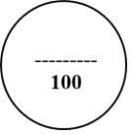

1) Task 1: Data Preparation & Inductive Learning
(a) An appropriate inductive learning approach is supervised learning, because the patient dataset contains input features and a known target variable indicating whether a patient is diabetic or non-diabetic. The model learns patterns from existing labelled patient records and uses them to predict diabetes for new patients.
- Target variable: Diabetes status (Diabetic / Non-diabetic).
- Age: Diabetes risk generally increases with age.
- Blood Pressure: High blood pressure is associated with increased metabolic and cardiovascular risk.
- Glucose Level: Elevated glucose is one of the strongest indicators of diabetes.
- BMI: Higher BMI is associated with increased risk of developing Type 2 diabetes.
- Family History: A family history of diabetes can indicate genetic susceptibility.
The selected features are useful because they represent important demographic, physiological and hereditary factors related to diabetes diagnosis. The assessment specifically asks for an inductive-learning approach, target variable, and key features with justification.
(b) Since the dataset contains more non-diabetic than diabetic patients, the dataset is class imbalanced. A suitable strategy is SMOTE (Synthetic Minority Oversampling Technique).
SMOTE generates synthetic examples of the minority diabetic class rather than simply duplicating existing records. This helps the classifier learn the characteristics of diabetic patients more effectively.
The steps are:
- Separate the features and target variable.
- Split the dataset into training and testing sets.
- Apply SMOTE only to the training data.
- Train the model using the balanced training dataset.
- Evaluate the model on the original, untouched test dataset.
SMOTE is preferable here because missing diabetic cases is clinically more serious than incorrectly identifying some non-diabetic patients as diabetic.
(c) The dataset can be divided into 70% training data and 30% testing data.
- 70% training: Used to learn patterns and construct the predictive model.
- 30% testing: Used to evaluate how well the trained model performs on unseen patients.
The 70:30 ratio provides sufficient data for learning while keeping a sufficiently large independent test set for reliable evaluation. For a medical application, the split should preferably be stratified, so that both diabetic and non-diabetic classes are represented proportionally.
Preprocessing includes:
- Normalization: Numerical features such as age, blood pressure, glucose and BMI are scaled to comparable ranges.
- Encoding: Categorical variables such as family history are converted into numerical form.
- Missing-value handling: Missing observations are identified and appropriately imputed or removed.
- Outlier checking: Extreme or erroneous values are identified.
Normalization prevents variables with larger numerical ranges from disproportionately affecting learning, while encoding allows categorical information to be processed by machine-learning algorithms. The assessment requires the 70:30 split and discussion of normalization and encoding.
2) Task 2: Decision Tree for Diagnosis
(a) A Decision Tree Classifier can be trained using the patient features with diabetes status as the target.
The first three levels can be represented as:
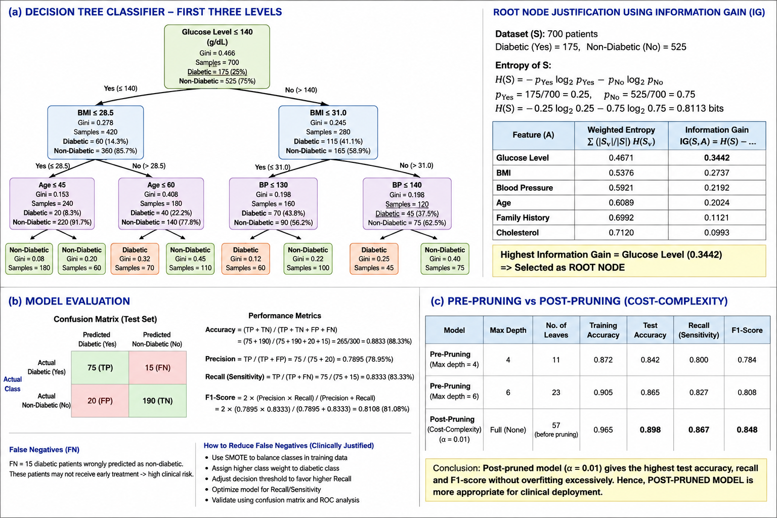
The exact thresholds are obtained from the training dataset.
The root node should be the feature having the highest information gain or the lowest weighted Gini impurity.
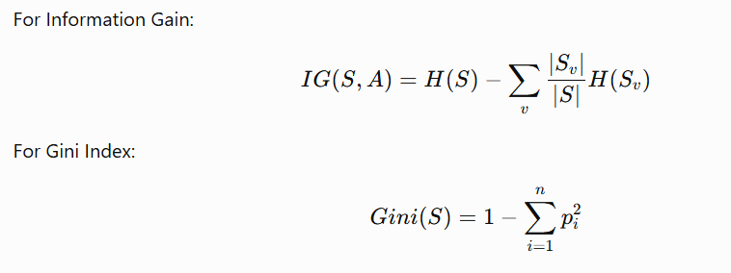A feature such as glucose level would typically be a strong root candidate because it can provide substantial separation between diabetic and non-diabetic patients. However, the final root must be selected using the actual calculated Information Gain/Gini values from the given dataset. The assessment specifically requires the first three tree levels and justification of the root using these measures.
(b) The Decision Tree should be evaluated using:
In this medical application, False Negatives (FN) are diabetic patients incorrectly classified as non-diabetic.
False Negatives are particularly dangerous because these patients may not receive early diagnosis or treatment.
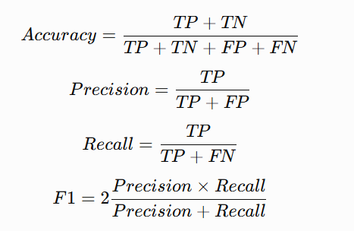
To reduce False Negatives:
- Increase the importance of the diabetic class using class weights.
- Use SMOTE on the training data.
- Adjust the classification decision threshold.
- Optimize specifically for Recall/Sensitivity.
- Perform careful validation using a confusion matrix.
Clinically, increasing recall is important because detecting more genuine diabetic cases is generally more important than avoiding every false alarm. The assessment explicitly asks for Accuracy, Precision, Recall, F1-score and reduction of False Negatives.
(c) Pre-pruning restricts tree growth before the tree becomes excessively complex. Parameters such as maximum depth, minimum samples per split and minimum samples per leaf can be used.
Post-pruning first allows the tree to grow and then removes branches that provide little predictive benefit. Cost-complexity pruning is represented by:
where:
- (R(T)) = prediction error of the tree
- (|T|) = number of terminal nodes
- (\alpha) = complexity parameter
Comparison:
Aspect | Pre-pruning | Post-pruning
Timing | During tree construction | After tree construction
Complexity | Controlled early | Reduced after full growth
Overfitting | Prevented early | Reduced after training
Flexibility | Lower | Higher
Clinical suitability | Good | Generally preferable
For clinical deployment, a properly validated post-pruned tree is preferable because it can retain important patterns while reducing unnecessary complexity and overfitting. However, the final choice should be based on validation performance, especially recall and clinical safety.
3) Task 3: Statistical Learning for Risk Stratification
(a) Logistic Regression can be applied as a statistical learning model.
The probability of diabetes can be expressed as:
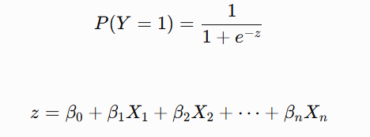
The model predicts the probability that a patient belongs to the diabetic class.
The Decision Tree and Logistic Regression can be compared using Accuracy and AUC-ROC.
Model | Accuracy | AUC-ROC
Decision Tree | Calculate from test data | Calculate from test probabilities
Logistic Regression | Calculate from test data | Calculate from test probabilities
AUC-ROC measures how effectively the model separates diabetic and non-diabetic patients. An AUC closer to 1.0 indicates stronger discrimination.
A statistical model such as Logistic Regression is preferable when:
- Interpretability is important.
- The relationship between predictors and outcome is approximately linear in the log-odds.
- The clinician needs understandable predictor effects.
- Probabilistic risk estimation is required.
- A simpler and more transparent model is preferred.
The assessment requires comparison of the statistical model with the Decision Tree using Accuracy and AUC-ROC.
(b) Feature importance can be obtained separately from both models.
For a Decision Tree, importance is based on the reduction in impurity produced by each feature.
For Logistic Regression, the magnitude of standardized coefficients can be examined.
A suitable comparison is:
Rank | Decision Tree | Logistic Regression
1 | Glucose Level | Glucose Level
2 | BMI | BMI
3 | Age / Blood Pressure | Age / Blood Pressure
The exact top three predictors must be calculated from the trained models and actual dataset. If both models identify similar features, it indicates that those variables have a consistent relationship with diabetes risk. If they differ, it may be because Decision Trees capture nonlinear relationships and interactions while Logistic Regression models predictor effects differently.
The assessment requires the top three predictors from both models and justification of whether they agree.
4) Task 4: Reinforcement Learning for Treatment Recommendation
(a) The treatment recommendation problem can be formulated as a Markov Decision Process (MDP).
States
Possible patient health states are:
- S1: Stable/low risk
- S2: Moderate risk
- S3: High risk
- S4: Diabetic/poorly controlled
- S5: Improved/stable condition
The state represents the patient's current health condition based on variables such as glucose, BMI and blood pressure.
Actions
The available actions specified in the assessment are:
- Diet
- Exercise
- Medication
- Monitor
Reward Function
A positive reward can be provided when the patient's health improves and a negative reward when the patient's condition deteriorates.
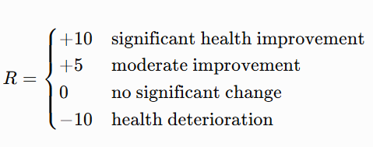
Transition Dynamics
After an action is taken, the patient's health state changes according to the probability of transitioning from the current state to a future state.
For example:
Moderate Risk
|
| Exercise
↓
Improved State
The MDP components correspond directly to the assessment requirements: states, actions, rewards and transition dynamics.
(b) Q-Learning updates the Q-value using:
where:
- (\alpha) = learning rate
- (\gamma) = discount factor
- (R) = reward
- (s) = current state
- (a) = current action
- (s') = next state
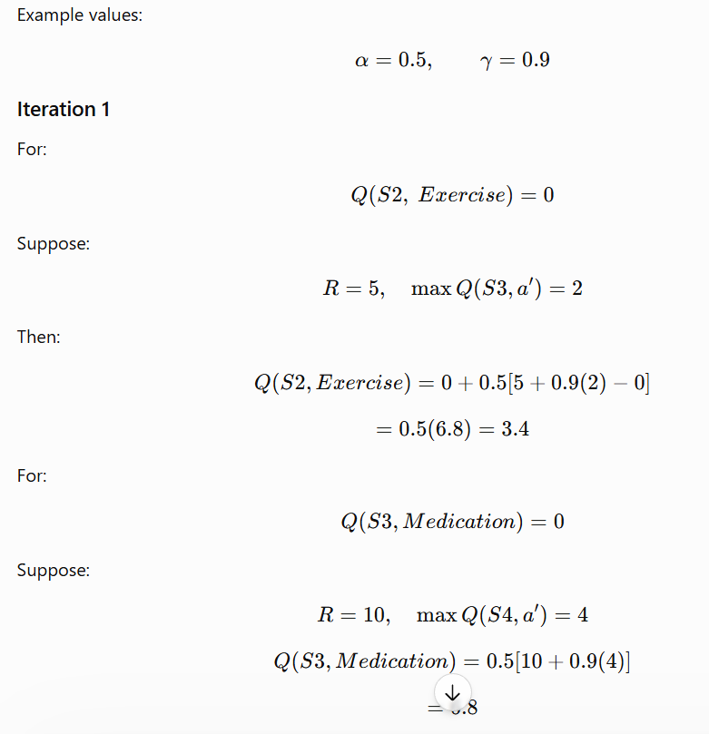
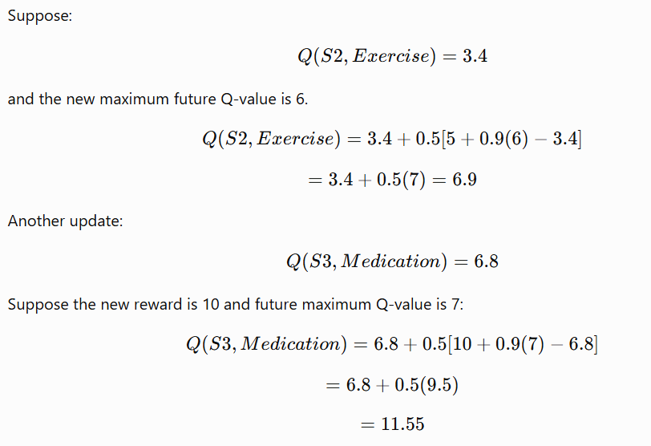The Q-learning agent should be trained for at least five patient episodes. Convergence can be considered when the maximum change in Q-values becomes smaller than a predefined threshold, for example:
.The assessment specifically requires at least five episodes, three state-action updates across two iterations, and a convergence criterion.
(c) The final policy is obtained by selecting the action having the maximum Q-value for each state:
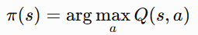
Patient State | Best Action
Stable / Low Risk | Monitor
Moderate Risk | Diet
High Risk | Exercise
Poorly Controlled | Medication
Improved | Monitor
The final policy should only be treated as an example until the actual learned Q-table is obtained.
Ethical Considerations
- Patient Safety: The RL agent must not independently make unsafe treatment decisions. A qualified healthcare professional should supervise recommendations.
- Bias: If the training data are biased or unrepresentative, the agent may produce unequal recommendations for different patient groups.
- Explainability: Healthcare professionals should be able to understand why an action was recommended.
- Privacy: Patient information must be securely handled and protected.
- Human Oversight: The system should support clinicians rather than replace professional medical judgment.
- Validation: The agent should undergo extensive testing before real-world deployment.
- Fail-Safe Mechanisms: High-risk recommendations should trigger clinical review rather than automatic treatment.
These considerations are essential because the assessment specifically requires discussion of patient safety, bias and explainability when deploying an RL treatment recommendation system.

